* Title of application

TaskMaster Pro

* Dates worked on application

Nov. 27

* Tasks accomplished

Rearranging the website and reorganizing the format

This version adds a more “modern” look to the webpage.

Transferring from the look of last week’s to the new look.

Adding a multiple functions to the website

Website has become more “enhanced”

Added testimonials’ section

The functions section introduces three key features: Task Management, Project Tracking, and Reporting, each with a brief description.

* Challenges faced and the solutions you implemented

The only challenge I faced was getting the approximate code in order to make the webpage look exactly like I wanted.

Making the background contrast with the color of the lettering

* Plans for the upcoming week

N/A.

* Outside resources utilized

Copilot Instructionals.

* Screenshots that show the progress from your plan until this final week

BEFORE

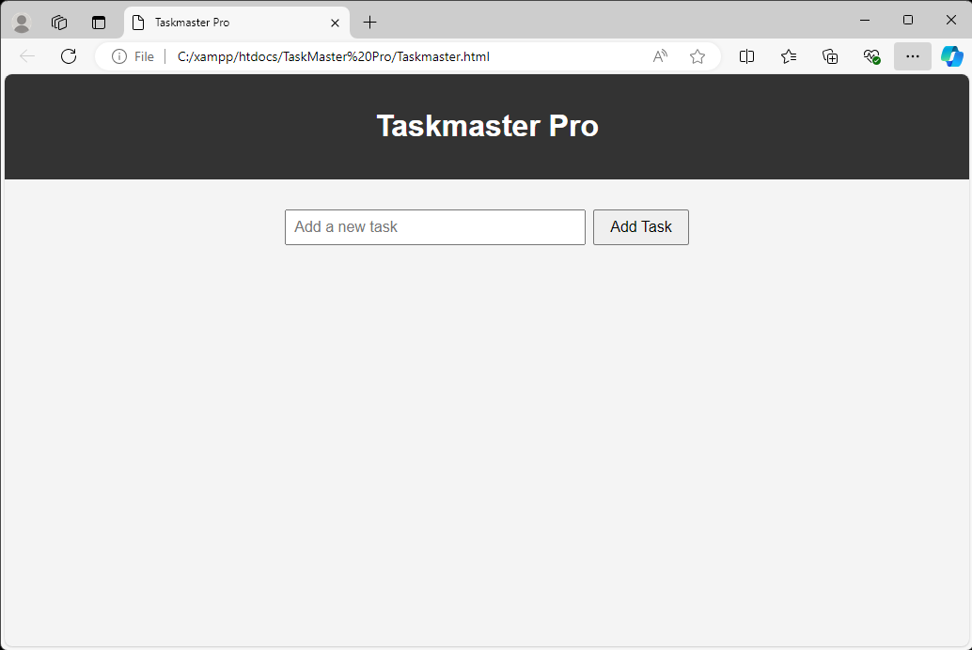

AFTER

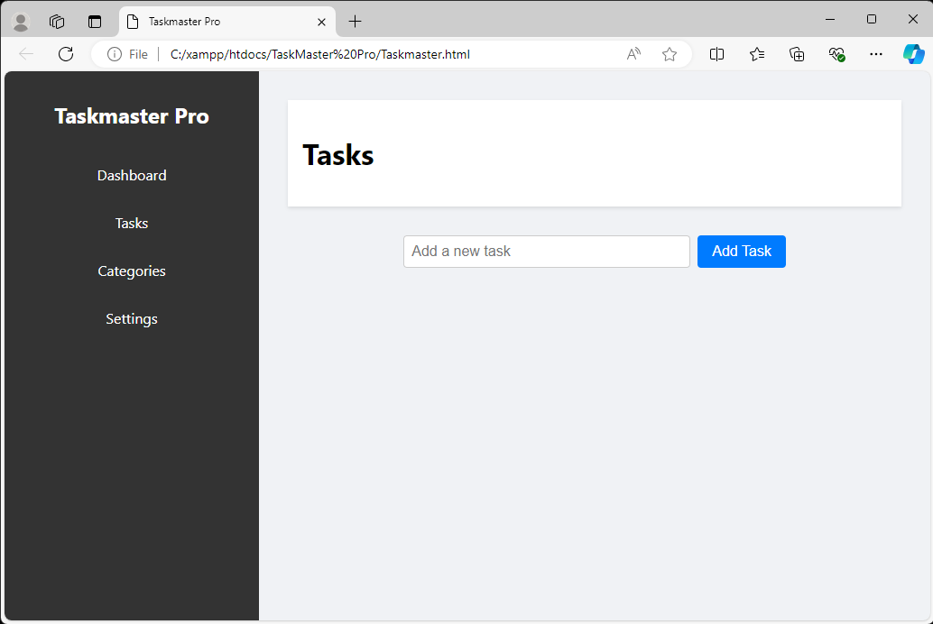

11/27

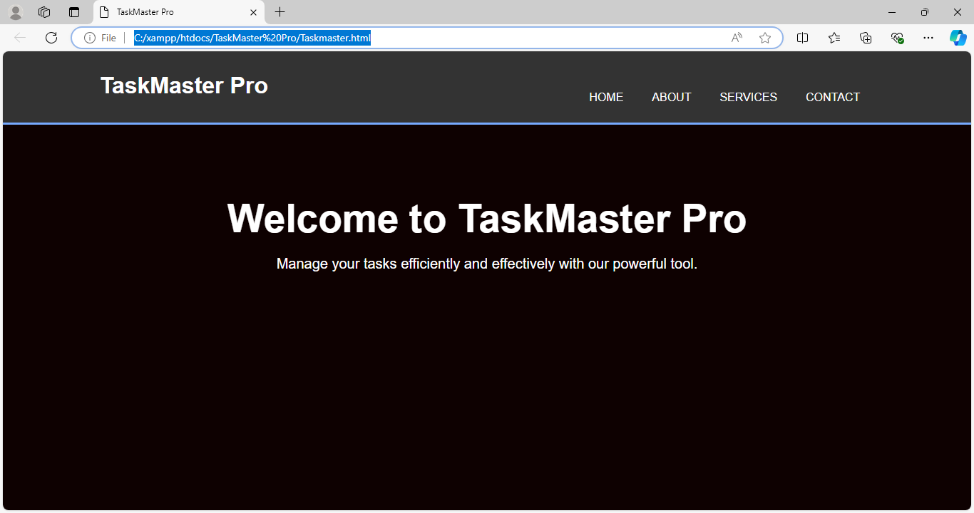

Week 5

